創業夢想家
^{STARTUP}CEO 計畫

Startup CEO Program
(請填寫公司/團隊名稱)
(Company/Team Name)
(請填寫產品/服務名稱)
(Product/Service Name)
產品營運計劃與團隊介紹
Product Operation Planning & Team Introduction

請注意：以下題目請照實填答，歡迎使用照片、圖片、表格等輔助說明，本份文件總頁數須不超過10頁總大小不超過 10 MB。 「此為範例，請參考」。
產品營運計畫 Product Operation Planning
Please note: Please fill out the following questions. Welcome to use photos, pictures, tables, etc. The number of pages must be less than 10 pages and the file must not exceed 10 MB.
一、請以一句話具體說明你的構想。Please specify your idea in one sentence.
健康舒肥雞胸肉系列列產品創業。

二、你們想解決甚麼問題？這是誰的問題？你們如何發現這個問題，並確信它有解決的價值？
What problem does your team want to solve? Who has this kind of problem?
How do you find this problem and be sure that it is worthy to solve it?
解決晚上重訓，但不知道吃甚麼的人的問題，故我們的目標市場是晚上有在重訓的人。
我們發現，晚上重訓的同學，可以重訓到9點結束，但9點結束後，附近如FD健康餐已結束營業。如去夜市的話，會有炸雞排、油雞之選項，這樣的飲食並不適合重訓族群。

三、針對上述問題，你們打算如何解決？你們的產品或團隊有何特殊之處，讓你們確信此解決方案會比現有解決方案更好？(本題請詳述產品/服務內容與特色，並需透過照片/圖片/概念圖等方式展現原型以上之產品。本題使用視覺化圖表、圖片輔助說明更佳。)
What is your plan to solve the above problems? What are features of your product/service and your team? And you believe that your product/service will be better than the existing solution? (Please describe your product/service in details and need to show the product/service prototype through photos, picture or concept map. It is better to illustrate your ideas with a diagram, a chart or a picture.)
我們希望可以配合重訓、晚上有運動課的同學，提供健康的飲食。另外，我們的產品將百分之百用健康的方式烹飪，可能用舒肥棒或水溫保持於60度烹飪。我們的產品會比較健康，符合此市場運動後需要補充健康蛋白質。

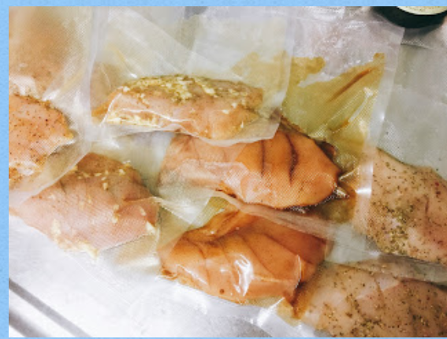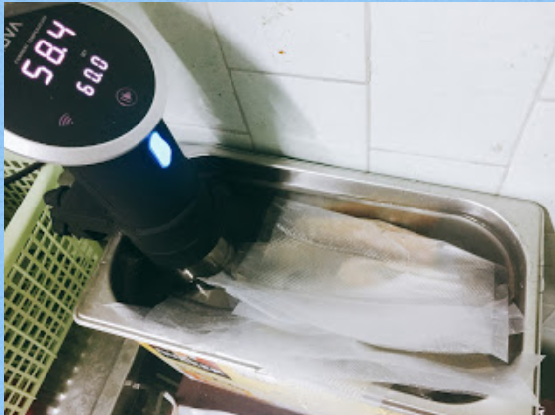
四、你們預計透過甚麼管道來獲利？ How does your team make profit?
夜市實體店面。虛擬如網站進行臉書廣告、GoogleAdwords廣告。

五、請描述你們鎖定的市場狀況，包括替代方案、與主要競爭者的優劣比較，以及你們如何決
定早期採用者是誰？
Please describe the conditions of your target market, including alternatives, comparisons your product/service against
major competitors and how do you decide who are your early target audience?

六、是否與目標族群諮詢過? 是否深度訪談或問卷調查過目標族群?
Have you consulted your target audience or conducted questionnaire investigation?

七、你希望未來半年在中原創業夢想家計畫達成甚麼目標？你預期如何協助你達成上述目標？若有你希望接觸與使用的業師/資源/服務，請直接寫出他的名稱。
What goals do you want to accomplish in the Startup CEO+ Program in the next six months? How can we help you achieve the goals? What are your expectations? What kinds of resources and service you need? Which mentors that you would like to consult about your goals, please tell us.

團隊介紹 Team Introduction
- 請介紹你們的團隊，包括你們如何組成、為何訂定此題目，以及團隊的目標與願景。
Please introduce your team, including how you are formed, why you select this subject, and your team's goals and vision.

- 請介紹你們的主要成員，包括他們過去的經歷、專長、性格、在團隊內扮演的角色，以及主要成員間如何互動與分工。
Please introduce your team members, including your experiences, expertise, personality and team member’s interaction and teamwork.

- 團隊成員過去是否有創業經驗？若有，請簡介你們的上一個題目，以及你們在其中的學習。若無，請舉一家你們最想當作標竿的新創公司，並說明為什麼。
Have team members had entrepreneurial experience in the past? If so, please introduce your last subject and what you learned from it. If not, which startup company is a model for your team and explain why?

- 請列出團隊重要的優秀事蹟、獲獎紀錄、曾參與之創業計畫、媒體曝光及其他重要里程碑等，讓我們更認識你。
Please list your team’s achievement such as reward records, entrepreneurial programs that have been involved, news about your team and other important milestones. Tell us more about you.

請勾選欲選擇之身分證明文件，並於本區塊貼上掃瞄或拍照圖檔證明
Please select one identity document and attach its scan file or image.
圖檔 Image：
□ 在學學生證 Student ID Card (still CYCU student)
□ 大學校友證 Alumni Card
□ 畢業證書 Certificate of Degree
□ 教職員證 Staff Card
（文件底端）(Bottom)
【注意】Reminder
- 填寫完成後，請另存為PDF格式，至申請系統上傳檔案。頁數10頁以內。
After completing the form, please upload it to the application system in PDF file. The number of pages must be less than 10 pages.
- 檔名格式請一律存為「公司/團隊名稱_創業夢想家計畫」
Please rename the file as“Company/Team Name_ Startup CEO+ Program”

